

Operation Manual

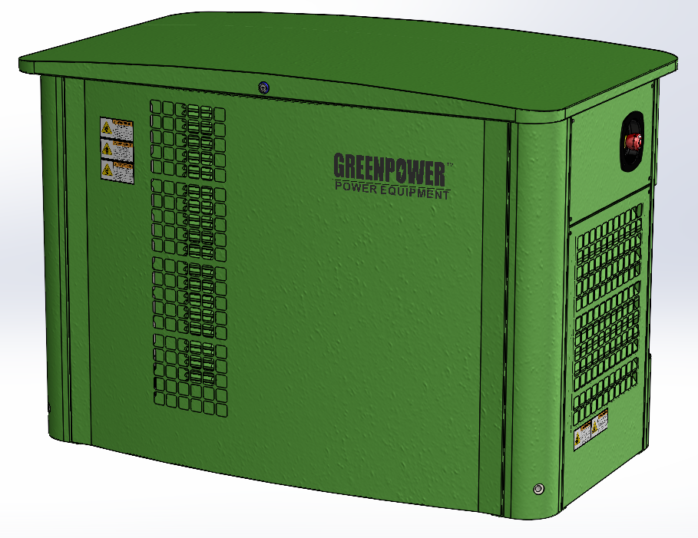

Model: GP19-NG/LPG
Please keep and read all instructions carefully before operation

It is highly recommended that the engine ID is recorded for future need of warranty, parts and service. It can be found stamped on the base of the engine block or on the outside of original shipping carton.

Preface

Thank you for purchasing this high performance, liquid-cooled, automobile engine-driven generator. This generator set is designed for use in stationary (permanent) applications where unreliable utility power may occur. Keep and read this manual carefully and follow all safety precautions and procedures in this manual to ensure proper equipment operation and to avoid bodily injury or property damage. Operating instructions presented in this manual assume that the standby electric and gas system has been installed by an authorized Service dealer or licensed and qualified contractor.

Installation of this equipment is not a “Do-It-Yourself” (DIY) project!!!!!!!!!


ATTENTION! Follow all safety precautions and instructions as outlined in this manual in its entirety. If any portion of this manual is not completely understood, please contact an authorized service dealer near you for installation, starting, operating and servicing procedures or contact us at No.. Common sense and strict compliance with these special instructions while performing service are essential to preventing accidents.

For professional advice on this product and its operating requirements, please contact a dealer near you or contact us directly at the information provided below. If you have any questions or suggestions, please contact us any time between 8:00 AM and 5:00 PM.

Warning Announcements!
Because this generator can be used as a single fuel or multi-fuel unit, pay close attention to factory settings. This unit can run on natural gas (NG) or propane (LPG).

Please pay attention to all factory settings! Unit comes already preset to one fuel or the other.

Before starting generator：
● Read the user manual carefully and operate generator according to factory recommendations.
● If you do not operate according to the instructions, it can cause personal injury or loss of life.

Tips and Warning Labels
Warning, Danger and Attention labels are provided to indicate the possibility of damage and personal injury when using generator. In addition, this information can indicate what kind of damage you could experience.

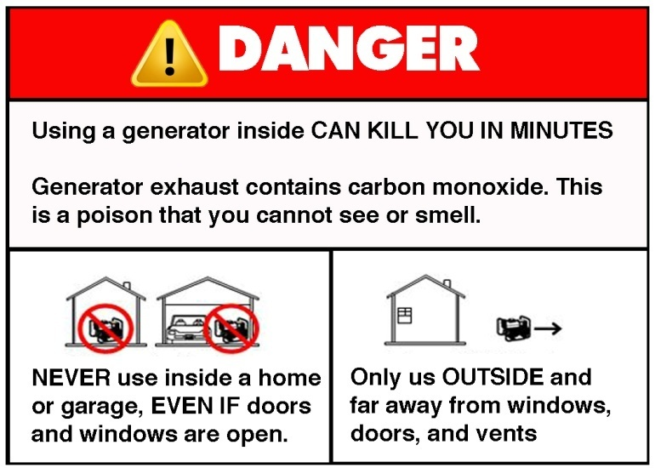
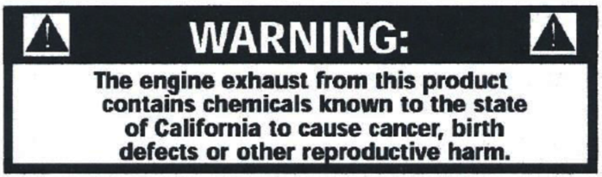
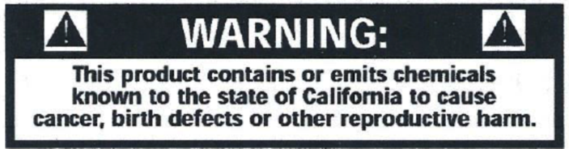


If you don’t follow the operational requirements, it could result in damage to the engine or related generator equipment.


If you don’t follow the instructions of the operating requirements, it could result in personal injury or other equipment damage.

If you don’t follow the instructions closely outlined in the operating requirements, it could result in serious injury or loss of life.
Users must operate in accordance with all requirements; otherwise it could damage the engine and genset.
This manual contains the following International ISO Graphical Symbols:
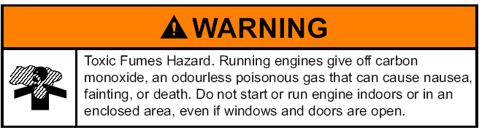

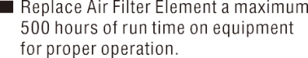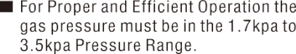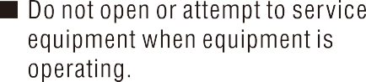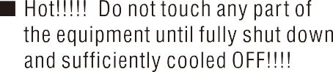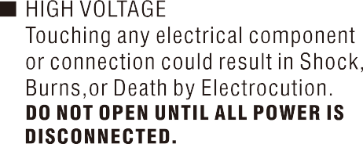
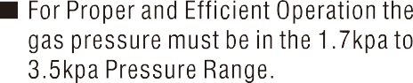

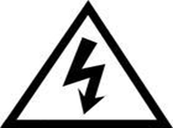



Save These Instructions – The manufacture suggest that these rules for safe operation be copied and posted in potential hazard areas. Safety should be stressed to all operators, potential operators and service technicians for this equipment.

Save These Instructions – This manual contains important instructions that should be followed during installation and maintenance of the generator and battery.

How to Obtain Installation, Parts
and Service

Contact Us at:
Address:
Tel:
Fax:
WWW.GREENPOWER.IR

Table of Contents

Engine ID…………………………………………................................................................... 1
Preface ……………………………………………………………………….…………....….…... 2
Tips and Warning Labels…………..………………………………….…………….....…........ 2
How to Obtain Installation, Parts and Service………………………...…………….……....…..... 5
Table of Contents ……………………………………………………………………………....….... 6
Chapter One………………………………………………………..……………………....…....... 7
- ● Technical Features………………………………………..…….....……............................ 7
- ● Specifications…………………………………………………………............................... 8
Chapter Two………………………………………………………………………....………..… . 9
- ● Important Safety Instructions……………………………………………................................ 9
- ● Warnings………………………………………………..………………………........................... 9
- ● Fuel System………………………………………………………………….…......................... 10
- ● Exhaust System…………………………………………………………….…....................... 10
- ● Grounding…………………………..…………………………………....................…...... 10
- ● Gas Vapors and Fuel Leaks……………………………..…….…......................….. 11
- ● Engine Noise…………………………………………………….…............................ 11
- ● Short Circuits………………………………………………………............................. 12
- ● Moving Parts…………………………………………………………......................... 12
- ● Operating System Functions and Definitions……………………........................... 13
- ● Emergency Stop Switch........................................ ............................................... 13
- ● Circuit Breaker………………………………………………………...................... ... 14
- ● Engine Pre-start and Preparation……………………………………........................…..... 14
- ● Engine Oil……………………………………………………………...........................…15
- ● Cooling System………………………………………………………......................... 15
- ● Fuel Conversation………………….……………………….…...........................….….. 16
- ● Battery………………………………………………………..………….......................….…... 17
- ● Starting Generator……… ……………………………..……………….. ........................ 20
Chapter Three………………………………………………………………….......………….…21
- ● Long Term Storage and Care……………………….……………………........................…. 21
- ● Starting after long periods of Storage………………………………………........................... 21
Chapter Four……………………..……………………………………………….......………..... 23
- ● Break in Period…………………………………..………………………….........................…. 23
- ● Lubrication System………………………..……………………….…….............................. 24
- ● Oil Level……………………………...…………………………………….........................….... 24
- ● Cooling System…………………………………………………………….........................…26
- ● Belts…………………………………………………………....................................... 27
Chapter Five……………………………………………………………………….........….... 28
● Specifications and Quick Start Stop Instructions…………………....……............................29
Emission control device or system maintenance............................................. 37

Chapter One: Technical Features

I. Technical Features of the Single Phase Dual-Fuel Generator
This gas generator is Dual-fuel and able to utilize both Natural Gas (NG) and Liquid Propane (LPG). It is a versatile multi-fuel engine. Based on our standards, we have designed this unit to operate in an environmentally safe and user friendly manor:
1. Speed Regulating System: This gas generator uses an internally designed electronic speed control system, allowing for quick and easy adjustments to the engine speed that can be set to specific speed ranges. This control system allows the engine to run more smoothly and respond quickly to sudden increases or decreases in required engine speed.
2. Silent Air In-take System: Extra-large air intake cross-sections in the housing enclosure ensures ample air flow for the engine and air in-take. This unique housing enclosure structure leads to a significant reduction operating noise.
3. Large Liquid Cooled Radiator and Reservoir: The use of an over-sized radiator and coolant reservoir, like those used in automobile engines, allows for additional radiator coil surface and helps maintain a more ambient and stable engine temperature even in the hottest climates. Utilizing this liquid cooled system adds to the life and long term operating dependability of your gas generator investment.
4. Automatic Transfer Switch (ATS) and Function: Automatic Transfer Switches are critical components of any emergency or standby power system. They are used for transferring essential loads and electrical distribution from one power source to another automatically, without personal involvement.
5. Intelligent Hazard Control System and Function: The Intelligent Hazard Control System warns of dangerous conditions that exist to the engine or generator. This system continually checks and monitors the unit’s operating conditions and will automatically shut down if detected, to help avoid costly damage. This system uses a visual control panel that can be preset according to the user's needs.

II. Specifications- for more detailed specifications see installation manual

Model# | GP19-NG/LPG | GP19-NG/LPG
RATED POWER(KW) LPG | 15 | 15
RATED POWER(KW) NG | 14 | 14
FREQUENCY(HZ) | 50 | 50
SPEED(RPM) | 3000 | 3000
RATED VOLT(V) | 220 | 380
RATED CURRENT(A) LPG | 68.1 | 28.4
RATED CURRENT(A) NG | 63.6 | 26.5
PHASE | SINGLE PHASE | THREE PHASE
POWER FACTOR | 1.0 | 0.8
PROTECTION LEVEL | IP 23 | IP 23

Chapter Two: Important Safety Instructions

SAVE THESE INSTRUCTIONS – This manual contains important instructions for the following models GP19-NG/LPG single-phase and three-phase units that should be followed completely during installation and maintenance of the generator and battery.

I. Warnings
- Generator Set Operation. Carbon monoxide can cause severe nausea, fainting, or even death. Carbon monoxide is an odorless, colorless, tasteless, nonirritating gas that can cause death if inhaled for even a short time. Avoid breathing exhaust fumes when working on or near the generator set. Never operate the generator set inside a building. Never operate the generator set where exhaust gas could seep inside or be drawn into a potentially occupied building through windows, air intake vents, or other openings.
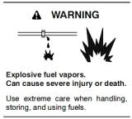
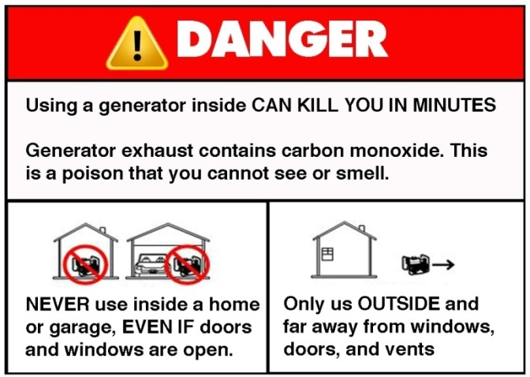

N'employezjamais à l'intérieurd'unemaisonou d'un garage, MÊME SI les portes et les fenêtressontouvertes. | Employezseulement EN DEHORS  et loin des fenêtresouvertes, des portes, et des passages.

Risquetoxique de vapeurs. Les moteurs courants dégagent le carbone
oxyde, un gaztoxiqueinodore qui peut causer la nausée, l'évanouissement, ou la mort. Ne mettez pas enmarcheou ne courez pas le moteur à l'intérieuroudans un secteurinclus, mêmesi les fenêtres et les portessontouvertes.

- Fuel System. Fuel Vapors are highly explosive and can cause severe injury or death. Use extreme care when handling and storing fuels. Store fuels in a well-ventilated area away from spark-producing equipment, gas hot water heaters and out of the reach of children. Never add fuel while the engine is running or hot, fuel spills may ignite on contact with hot parts and muffler. Do not smoke or operate around sparks or open flames. Keep fuel lines and connections tight and in good working condition.



3. Servicing the Exhaust System. Hot parts can cause severe injury. Do not touch hot engine parts. The engine and exhaust system components become extremely hot during operation.
4. Servicing the Engine. Hot parts can cause personal injury or property damage. Install (optional feature, sold separately) engine block heater for extreme cold weather before connecting it to power (See separate installation instructions). Operating the engine block heater before installation can cause burns and component damage. Disconnect power to the engine block heater and allow it to cool before servicing the heater or nearby parts. Keep the generator at least 2m（6ft）distance from other devices.

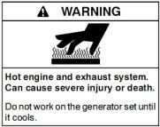
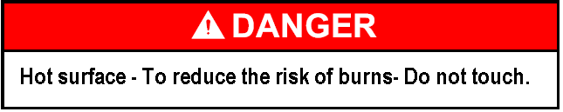

Grounding Generator

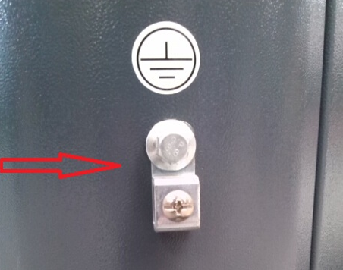

5. Grounding Electrical Equipment Hazardous voltage can cause severe injury or death. Electrocution is possible whenever electricity is present. Ensure you comply with all applicable state and local codes and standards. Electrically ground the generator set, transfer switch, and related equipment and electrical circuits. Turn off the main circuit breakers of all power sources before servicing the equipment. Never contact electrical leads or appliances when standing in water or on wet ground because these conditions increase the risk of electrocution. It is highly recommended that a barrier exist between you and the ground surface. We recommend using a wooden pallet with rubber mat on top to stand on while working or servicing the standby generator.
Grounding is required of all AC circuits, use terminal (identify terminal)for bonding this circuit to the enclosure with a grounding rod (Not provided with unit). Ground the enclosure to a grounding electrode in accordance with state and local code requirements.

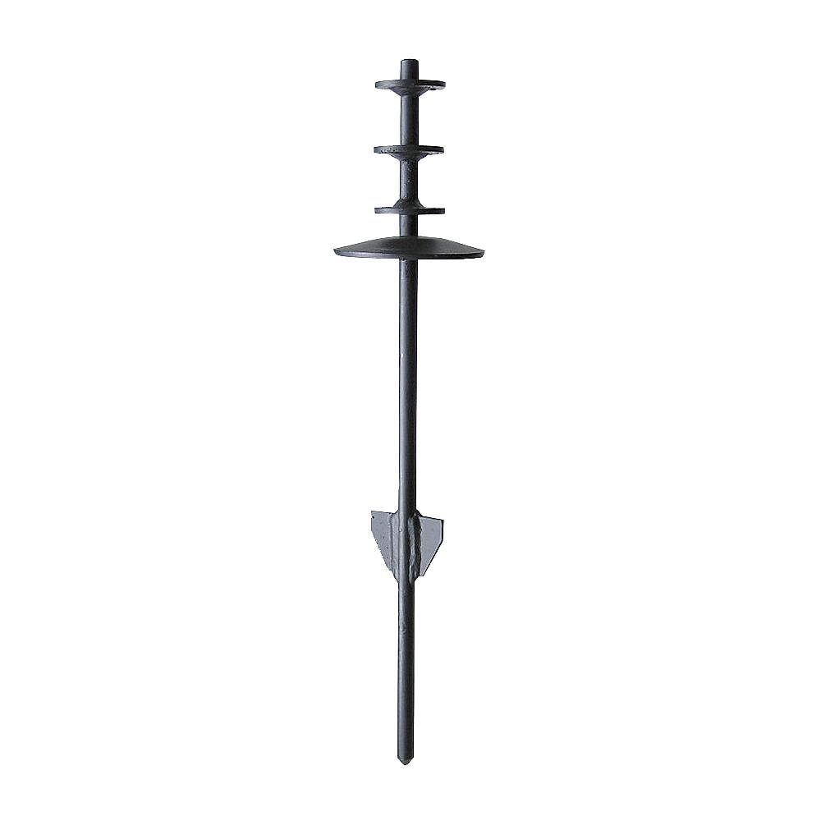

6. Gas Vapors and Fuel Leaks. Explosive fuel vapors can cause severe injury or death. Fuel leaks can cause an explosion. Use digital gas leak detector on all gas connections for no less than 1 minuet per connection. Leak detector not included with generator. Contact Service provider.

7. Engine Noise. Hazardous noise can cause hearing loss. Generator sets not equipped with sound enclosures can produce noise levels greater than 105 dB. Prolonged exposure to noise levels greater than 85 dB can cause permanent hearing loss! Wear hearing protection at all times when working near an operating generator set.
8. Short Circuits. Hazardous voltage/current can cause severe injury or death. Short circuits can cause bodily injury and/or equipment damage. Do not connect electrical contacts with tools or while wearing jewelry when making adjustments or repairs. Remove all jewelry before servicing the equipment.
Electrical back-feed through the utility power supply can cause severe injury or death. You must install a manual or automatic transfer switch on all standby power applications and installations. This is to prevent the back-feeding of electrical current through power lines causing fire, severe injury or death to utility personnel working on power lines.

9. Moving Parts. When the generator set is in operation, the cooling fan is rotating. Do not open the maintenance cover and make adjustment while generator is running. Please shut down the engine and turn electrical breaker in off position before maintenance or operation. Before restarting, close all service panels.

10. CAUTION: FOR STANDBY ELECTRICAL OUTPUT, CONNECT GENERATOR TO SUITABLY RATED TRANSFER SWITCH IN ACCORDANCE WITH THE CANADIAN.

ELECTRICAL CODE, PART I. THIS UNIT REQUIRES A 200amp TRANSFER SWITCH.

ATTENTION: POUR L’ALIMENTATION DE RÉSERVE, CONNECTER LA SORTIE DE LA GÉNÉRATRICE À UN COMMUTATEUR DE CALIBRE APPROPRIÉ CONFORMÉMENT AU CODE CANADIEN DE L’ÉLECTRICITÉ, PREMIÈRE PARTIE.
11. THERE IS A PERMANENT CONDUCTOR BETWEEN THE GENERATOR (STATOR WINDING) AND THE FRAME.
IL Y A UN CONDUCTEUR PERMANENT ENTRE LA GÉNÉRATRICE (ENROULEMENT DU STATOR) ET LE CADRE.
12．Keep top cover locked at all times with provided key. Keep key stored in safe place out of the reach of children. If key is lost please call No..

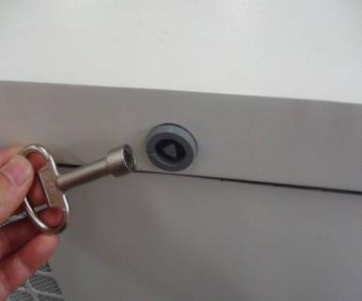
II. Operating System Functions and Definitions
Depending on the generator unit model, control button functions may vary significantly. Refer to the following functions:
1. Operating System
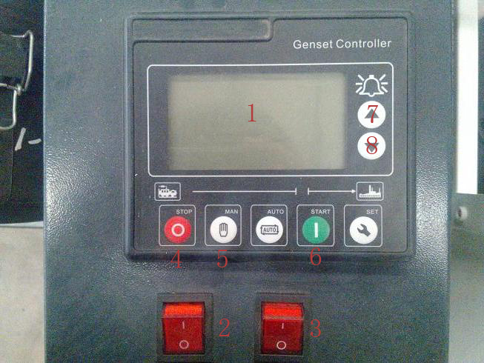
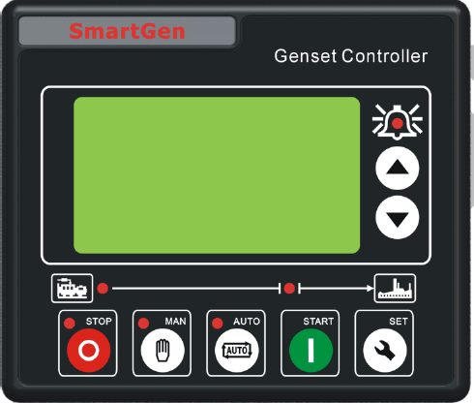
Auto
1. Control panel
2. Power switch
3. Fuel switch
4. Stop
5. Manual Start
6. Auto Start
7. Data check up
8. Data check down

Power Switch：
Function：The power switch controls the entire generator set control system. If this switch is placed in the OFF (O push in down mode) position, the internal electrical control circuit of the unit will not have any electrical power. When this switch is placed in the ON (I in the up mode) position, the control system can be automatically started with ATS, tested and run.

Fuel Switch：
Function：The fuel switch allows the fuel to flow to the engine when placed in the ON or ( I ) is in the up position. Likewise, the switch turns the flow of fuel off to the engine when placed in the OFF (O) push down position.

Emergency Stop Switch:
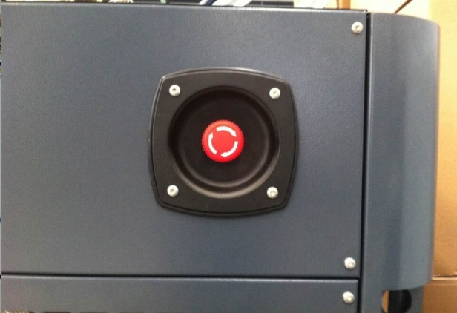
Function：The photo above shows Emergency Stop Switch on outside corner of unit.

Locate on the side corner of generator. When depressed, all generator control systems will immediately shut down, including the engine and generator head. The Emergency Stop Switch should be pressed immediately should any unexpected emergencies occur. Depressing this button will help minimize dangerous damage to persons, pets, property, plants, or to the generator unit itself.
Use：When an emergency situation occurs, immediately press the Emergency Stop Switch. The unit will automatically shut down. Once the switch has been depressed and the emergency situation has passed, to re-start the generator unit, rotate clockwise 90 ° to pop up into the normal operational position.

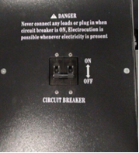
Circuit Breaker:
Function：The circuit breaker controls the ON/OFF functions of the generators electrical power output. When this switch is in the up (ON) position, electrical power output will be produced and flow normally. When this switch is placed in the down (OFF) position, electrical power output will be broken, or turned off. However, as a safety function, when this switch is placed in the ON position, the production of a too large of an electrical load or a short circuit due to faulty operation, the switch will immediately and automatically switch to the OFF position in order to protect the generator from damage. Should this occur, turn off the generator unit and correct the cause before restarting and placing the circuit breaker in the ON position.

Use：When starting manually, always start the generator before placing the circuit breaker in the ON position. Likewise, when operating manually, place the circuit breaker in the OFF position before shutting the generator down.

III. Engine Pre-start and Preparation
All necessary installation and maintenance must be conducted and performed by authorized licensed personnel.

Before starting engine for the first time, engine oil and radiator coolant must be added. An initial fluid inspection and pre-check is recommended before starting genset for the first time or when unit has been in operation for over 20 hours. It can also be used as a quick review of all fluids. Check all of the following items before running system for the first time.

IMPORTANT NOTE! Unit is not shipped with engine oil or coolant from Factory!!
After installment of generator, fill engine with recommended oil weight based on ambient temperature shown below and add radiator coolant. Prior to initial start-up, replace all service panels and close lid. Start engine and allow 10 minutes for system to warm-up. After this has been performed remove service panels rise lid and check for any leaks or drips. If found, tighten lose hoses, clamps or plugs. Recheck all fluid levels and top off as necessary.

1. Engine Oil. The unit is not shipped with oil from factory!!! Use high-quality detergent oil “Classified for Service in CC, SD, SE, or SF use” Only use oil having the following SAE viscosity ratings. Fill with the recommended amount of oil as specified. Overfilling or under filling can cause damage to the engine. Use the following recommended or similar type engine oil.
Temperature | Recommended Oil Grade
Below 32° F (0° C) | SAE 10W or 15W-40
32° to 80° F (-1° to 27° C) | SAE 20W or 15W-40
Above 80° F (27° C) | SAE 30W or 15W-40

● Place funnel in engine oil inlet.
● First time operation will require 4 liters or (4.25qts) of oil.
● Check oil gauge dipstick regularly, oil level should be kept between top and bottom lines, at all times. It is preferred to be at the top mark but not over.

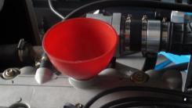

2. Cooling System
Use only automotive grade antifreeze and distilled water in cooling system.
Do not use water that contains salt or alkalis (Tap Water)! Using non-distilled water creates scale in the radiator causing corrosion and premature wear.

You must check and maintain all fuel, lubricant and coolant levels. Not doing so will accelerate and shorten the life of the standby system. Attention must be paid to all fluid systems and annually serviced buy an authorized service provider or call No. for assistance.

3. Fuel Conversion

Do not touch hot engine parts. The engine and exhaust system components become extremely hot during operation.

Two fuel connections on the fuel block allow field conversion between natural gas (NG) and Liquid Propane (LPG). The fuel metering valves are factory-set and sealed to provide the best possible hot and cold starting.

Use the following procedure to convert fuel from one type to another:
Natural Gas (NG) and Liquid Propane (LPG) Conversion
● Use a pressure reducing valve to reduce LP pressure supply.
● Pushing the button as attached pictures below to the natural gas or LP vapor per the fuel which you want to use.

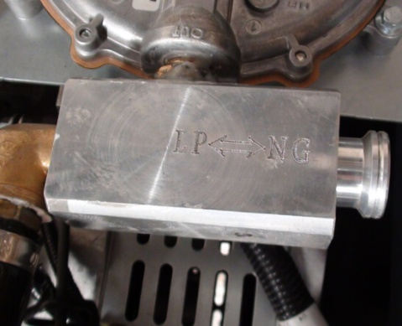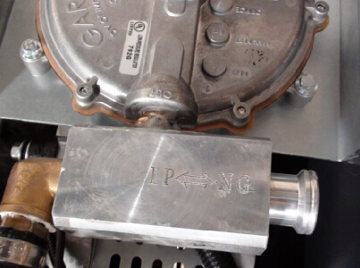
LPG--IN NG--OUT

A. Liquid Propane (LP Vapor)
In engines set up to run on Liquid propane, please check the fuel supply pressure, lower or higher pressure range will result in equipment failure. Inlet pressure 1.7kPa to 3.5kPa, and gas line should be no longer than 16 feet or 5 meters, the inner diameter shall not be less than (0.63”) or 16mm.
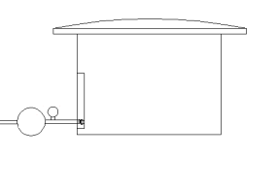
Pressure Meter

Pressure Relief Valve

It is strictly prohibited to remove high pressure gas lines during maintenance, service and repair. You must check and test for gas leaks using a gas leak detector before use. The observation time is not less than 1 minute per connection.
Based on different gas sources that are available, there may be different gas pressures present. Make sure pressure is known before installation. A pressure reducing valve may be required to obtain optimal requirements. You will need to use a pressure reducing valve if the pressure is excessively high. Tools such as leak detectors and pressure gauges are not included with this purchase.

B. Natural Gas
If engine set to run on natural gas from factory, please check the fuel pressure and flow. The purchase of a pressure reducing valve might be required and not included with this unit.

CAUTION! After installation please contact service provider if user wants to switch fuel types from Natural Gas (NG) to Liquid Propane Gas (LPG) or vice versa. Please contact the seller, installer or manufacture at No..

4. Electrical Connections
If the generator set is used for standby power, install properly sized automatic transfer switch (ATS) provided by manufacture. This will prevent inadvertent interruptions of standby power and normal sources of supply. Always shut down generator before servicing the equipment. Never contact electrical leads or appliances when standing in water or on wet ground because these conditions increase the risk of electrical shock.

5. Battery
Connect positive lead wire first (+) and then negative lead wire (-) to matching positive (+) and negative (-) terminals on battery. Connect negative（-）lead last!!!!!

IMPORTANT! The generator will not start and circuit board damage can occur if battery is connected in reverse.

(Before initial use the maintenance free battery should be tested for voltage, if >12.6V,it can be installed and used immediately; After first time use or <12.6V it should be re-charge before use.)
For first time use, you should operate according to the steps bellow:
● Installing battery - take off red cap on positive battery terminal.
● Use a multi-meter to check voltage of battery before installing and starting. If reading is below 12.6V, recharge battery.
● Loosen positive battery clip. Connect positive terminal fully and adjust direction. Tighten terminal nut on battery clip and place red rubber cover over terminal.
● Follow the same steps for negative or black battery lead, then place rubber cover over terminal.
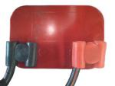

The battery represents a risk of high short circuit current. When working on the battery, always remove watches, rings or other metal objects, and only use tools that have insulated handles!!!!!!!!!

Installing, Servicing or Exchanging the Battery should be performed or supervised by knowledgeable personal. Battery connection or exchange requires precautions and protective gear. Always wear face and eye protection with electrical rubber gloves, boots and battery apron. Keep unauthorized personnel away from battery.
When replacing battery, always use the same size battery and number type: 12V, Lead-acid battery.
CAUTION – Do not dispose of battery or batteries in a fire. Batteries are capable of exploding.
CAUTION – Do not open or mutilate the battery. Released electrolytes have been known to be harmful to skin, eyes and to be toxic.

6. Grounding
Make sure the generator set is grounded. Check grounding strap to make sure the generator set ground terminal.

7. Starting Generator
1) Digital display #1.
2) Turn on the power switch #2.
3) Turn on the fuel switch #3.
4) After 10seconds manually press #5 on control panel.
5) Press #6 to initiate system start.
6) Press 7 through 8 to observe frequency, voltage, speed and the 12V working voltage and operation time.
7) After the unit has started it will automatically sync with ATS and enter into automatic mode.

The emergency stop switch, power switch and fuel switch must be kept in the on position for automatic start-up.

8. Inspection of Generator Set when Operating.
1) Radiator and Coolant Level. After warm-up, check the coolant flow in system by rising
lid to make sure coolant is circulating. If no coolant is visible flowing through hose to coolant reservoir, shut down the engine. Allow engine to cool down, and remove the radiator cap.

Check-lists：
● Check for fluid and coolant leaks.
● Inspect inside and out of the radiator to ensure no excessive dirt is present.
● Check the radiator coils and ensure no dust, dirt or foreign debris exists.
● Check hoses to ensure it is not blocked.
Add additional coolant to recommended levels.

2) Fault Indicator Lamp
When red lamp indicator is illuminated, operator must shut the generator down and follow trouble shooting guide and steps.

If the generator still won’t start, press the emergency stop switch. Rotate clockwise to pop up position. After waiting for 30 seconds, try starting again. If generator still cannot be started, check the generator carefully for loose wires, battery terminals and voltage output, gas flow to the lines and generator.

If after restarting the generator, the fault indicator light is still red, the generator will automatically shut down. Retrace steps in trouble shooting guide and procedures again. After correcting the fault, the generator is able to be re-started. If the fault indicator light remains off, then the generator is operating normally. If not contact your local service provider or contact us by calling No..

It is important to confirm after starting that the normal electrical output range is not exceeded as this will damage the generator.

3) Exhaust Color
As long as the generator engine is running within the rated output range,
a) The exhaust will be colorless.
b) If the exhaust is dark grey or black after running for 60 seconds or more, this is an indication of an engine problem. Shut the engine down and contact your local service provider or contact us at No..

4) Other Problems requiring shutting down of the Generator
You should shut down the engine if the following circumstances happen.
● The engine speed is hunting ( inconsistently speeding up and down)
● An abnormal noise is heard coming from the generator or engine.
● The engine exhaust suddenly turns dark grey or black.
● The fault indicating light is illuminated.

9. Shutting down the Generator
Should a need occur to shut down the generator, shut down the electrical output first by turning the circuit breaker to the “OFF” position and depress the reset key. This will automatically shut the engine and generator down.

The power switch (#2) needs to be in the open or on position if connected to the ATS system in order for the unit to start automatically.

Chapter Three: Long term Care and Storage of Generator
I. Long Term Storage and Care
1. Remove battery positive lead first and then negative lead. Remove battery and store in dark dry place. It is recommended to recharge it slowly every three months.
2. Turn Gas line to generator in off position and disconnect. Plug gas line with rubber plug to prevent dirt from getting into gas line.
3. Remove all dirt from the generator if long time storage is needed.
4. Drain coolant from engine. Place drain pan under pre plumed coolant line and open valve allowing all coolant to drain (See page 26).
5. Drain oil from engine. Place drain pan under pre plumed oil line and open valve allowing all oil to drain (See page 26).
6. Ensure engine is in good technical condition, keep all surfaces clean.
7. Remove all spark plugs, pour 1oz or 30grams of engine oil in each spark plug opening, turn crankshaft 20 turns slowly to allow oil to coat inside of cylinders and pistons, and then re-install spark plugs.
8. Use dewatering Vaseline (heat range 100°-200°F) wipe on the surface of contacts.
9. Add light amount of penetrant oil to all, hinges, bolts and moving parts.
10. Use clean canvas or cloth to cover the engine and keep it dust-free.
11. Store and cover in a warm clean room with temperatures above (5°C, 41°F) relative humidity should be kept between 40-70%.
12. Check all loose nuts, bolts and screws.
13. Seal gas line inlet valve with rubber plug to keep gas line free of dust.
14. Push the emergency stop button.
15. Cover the generator with the dust-proof cover, and keep it in the dry and clean place.
16. Keep it in well ventilated, dry rainproof area and away from flammable and explosive materials.
II. Starting after long periods of Storage
1. Wipe and remove protective lubricants from all contacts.
2. Remove spark plugs one at a time to remove 1oz or 30grams of engine oil from cylinders. Use clean rag and place it in each spark plug opening and turn engine over slowly allowing oil to soak into clean rag. Repeat this process for each cylinder.
3. Add light penetrant oil to all hinges.
4. Add coolant.
5. Add engine oil.
6. Check all wires and hose connections.
7. Install battery connecting positive lead first and then negative lead.
8. Reconnect gas line and check for leaks using a digital gas detector.
9. Start engine to make sure operation is normal.
10. If belts are making noise, shut down generator, allow to cool down and then tighten belts as needed.
11. Check all electrical parts and digital display for normal working conditions.
12. If red indicator light on display panel is illuminated, perform trouble shooting procedures. See trouble shooting guide.

Chapter Four: Maintenance of Generator

Regular maintenance is an important part of your investment and provides longevity of the complete generator system. Keeps it in good working condition according to the specifications outlined and it will provide many years of dependable service.
The following generator maintenance specifications are based on a good working environment. If working conditions are less than desirable, (such as excessive dust, dirt and humidity, etc.)the maintenance interval periods should be shortened.
When maintaining the generator set, you should operate in strict accordance with the following requirements. Improper use and operation can cause premature failure.

I. Breaking-in Period of New Engine
The life of the engine is greatly determined by the state of the first cycle of use. It is recommended that the oil be replaced after only 10 hours of use on the first cycle The new engine should be operated as required. Abnormal engine ware will directly affect the life of generator engine.

II. Maintenance of the Fuel System
The genset is multi-fuel and comes preset from the factory to ether Natural Gas (NG) or Liquid Propane (LPG), Maintenance will vary according to the fuel used.
Fuel is flammable and an explosive material. Smoking is prohibited while working or servicing generator.

When using Natural Gas (NG) or Liquid Propane (LPG)
● Before each operation, you should check all components for loose connections. Check for fluid leaks around cylinders, pipes and hoses. Tighten as needed.
● Periodically check the gas pressure reducer and the solenoid valve sealing pad for deformities.
● Periodically check the low-pressure gas line to see if it has weathered or aged (soapy water can be used to detect leaks).
● When maintenance of the gas line is required, gas valve must be closed before any maintenance or repairs are carried out.

III. Maintenance of the Lubricating System

1. Engine Oil
Oil viscosity: Select the viscosity brand according to the ambient temperature.
Oil quality level (according to standards set by the American Petroleum Institute): API SE SP SG or higher-level oil.
After 30 hours of running new engine, the oil must be replaced. Only maintain and replace the amount of oil according to the requirement, this will ensure long dependable engine life. Recommended oil: Shell, Mobil 1, Valvoline or similar oil quality.

Do not mix different grades and detergents of oil.
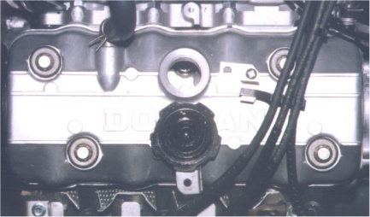

2. Replacement of old engine oil
Replacing engine oil: This unit comes with pre-drain hoses already installed from the factory for ease of service. See photo on next page.
● Start the engine for several minutes to increase the temperature of the engine oil and then stop the engine.
● Place pan under the oil drain hose. Open oil drain valve to drain out all engine oil.
● Close oil drain valve and replace with recommended oil amount.
● Start engine and allow new oil to circulate and fill oil filter for three minutes. Make sure there are no visible oil leaks!
● Shut down unit and top off oil as needed. Oil level should be between A and B marks on the dipstick, it is preferred that the level be close to B mark but not over!

Water Drain Pipe Oil Drain Pipe
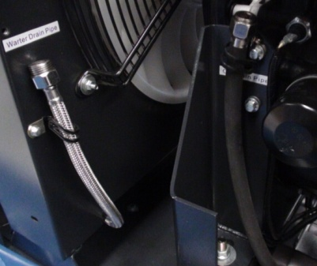

3. Replacement of used oil filter with new oil filter
Replace old oil filter after the engine has cooled. The replacement cycle should be followed according to the maintenance cycle schedule.
Steps for replacement：
● Use oil filter wrench to remove old oil filter. Turn to the left to loosen.
● Before installing new oil filter coat, gasket surface with a thin layer of oil before installation.
● Twist new filter to the right to tighten into place with a firm hand. Do not over or under tighten filter.
● Start generator and run for several minutes. Check for leaks. Shut down unit and check oil level using dipstick. Oil level should read between point A and point B on dipstick. If needed add additional oil. Do not over fill.

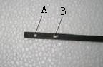
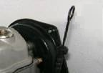

Use oil filter wrench if needed but don’t over tighten, the recommended torque is between 15N.M-20N.M. Disposes of used oil and filter properly and do not pour down drain or on ground.
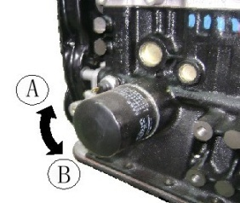

Direction A：Tighten Direction B：Loosen

IV. Maintenance of the Cooling System
When the engine is operating, there must be enough antifreeze and distilled water in the radiator system to insure proper engine cooling. It is suggested to check it regularly before use, if there is not enough antifreeze or distilled water add as needed. Do not use mineral, hard water or poor quality antifreeze. We suggest Prestone, Shell, Texaco or similar brand.
1. Replace antifreeze and distilled water as outlined in the service guide or if discolored to a brown watery mix. Combine antifreeze and distilled water only to manufactures suggested guidelines.
Do not replace cooling liquid when the engine is hot.
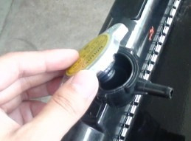

After prolong use or time, the coolant can go bad and discolor. Follow the recommended steps as outlined below:
● Place pan under pre plumed coolant or water line pipe. See photo below.
● Open coolant or water line pipe valve and allow it to drain completely.
● Remove or wipe any old excess water.
● Close coolant or water drain pipe line valve.
● Refill radiator cooling system and reservoir until full.
● Start the generator without load for a few minutes. Allow for air pockets in the system to settle. Shut down generator and add additional coolant as needed until the level remains steady.
● Shut down generator again and add coolant to the “FULL” level mark.
● Make sure the expansion tank is filled half way between low and full mark.
● Install radiator cap and expansion tank cover. Inspect system carefully to make sure there are no leaks.

Hard water, mineral water and saline water is harmful to the engine and cooling system. Do Not Use!

2. Routine Radiator Maintenance tips:
● Regularly check radiator hoses. Inspect clamps and make sure they are secure.
● If hoses become deformed, develop bulges, hardening or cracking is visible they need to be changed immediately!
● Inspect and clean the cooling fins on the radiator regularly, use compressed air to blow out excess dust and dirt. Important! Blow compressed air from the inside out. Debris can build over time and affect the cooling system.
3. Routine Belt inspection tips:
Adjust and replace the water pump belt as needed. Inspect it regularly for cracking or missing pieces of rubber.

Pump belt is extremely important. It drives the water pump that cools the engine and entire system.



Note: Listen for sounds coming from the belts. If you hear the belts squealing when the generator starts up, this is a sign that the belts are loose or worn and the system will run hot! If belts show signs of cracks or pieces of belt are missing, contact service provider.

Important! To check to see if the belt is too tight make sure the main power switch is in the off position. Perform the following inspections and adjust or replace belt as needed.

Deflection check of the belt：7～10mm（0.28-0.35in）∕100N｛10.01kgf（22.1 lbs.）}
Adjust the deflected belt：
● Stop the engine.
● Use thumb to press on the belt between pulley wheels.
● If the tightness is not correct, adjust it by relaxing the tension wheel to the acceptable degree.
● Replace the water pump belt when it is cracked, missing pieces of rubber or singes of considerable wear.

Chapter Five

- Specifications
- Basic Dimensions
Genset Wiring Diagram
- Control Features
- Transfer Switch
Available Accessories(Sold Separately)
200A ATS Single Phase Wiring Diagram
200A ATS Three Phase Wiring Diagram

Specifications for GP19-NG/LPG
Model | Weight | Size | Sound
GP19-NG/LPG | 772lbs(345kg) | 54.17in×31.89in×37.80in | 72dB(A) at 23ft(7m)
GP19-NG/LPG | 772lbs(345kg) | 54.17in×31.89in×37.80in | 72dB(A) at 23ft(7m)

Model | Phase | Voltage(V) | Frequency(Hz) | Rated Amps  (NG/LPG) | Circuit Breaker  (Amps)
GP19-NG/LPG | 1 | 220 | 50 | 68.1/63.6 | 69
GP19-NG/LPG | 3 | 380 | 50 | 28.6/26.5 | 29
Derating guidelines: Engine power available up to 1005m (3300 ft) at ambient temperatures up to 40 °C (104 °F). Above these elevations derate at 4% per 305m (1000 ft) and 2% per 10 °C above 40 °C (104 °F)。

Manufacturer/Model | 465QR
Engine Type | 4 Cylinders, 4 Stokes
Displacement | 0.998 liters(60.9in³)
Bore | 65.5 mm(2.52 in)
Stroke | 74 mm(2.91 in)
Compression Ratio | 9.5:1
Ignition System | ECM
Intake Air System | Naturally Aspirated
Starter Motor Rated Voltage | DC 12V/0.8KW Electrical Start
Battery Charging Alternator | DC 14V/70A
Oil Capacity | 4.0 liters(244.1 in³)
Air Cleaner Type | Dry
Recommended Cold Cranking Amps:(CCA) rating for －18℃ (0℉) | 550
Engine Cooling System
Cooling system | Closed Liquid Cooled
Coolant Capacity | 5L
Coolant Temp Range | -25℃～106℃
Radiator Fan | 7 BladeΦ380
Fuel
Fuel Type | Natural Gas or LPG
Fuel supply pressure, kPa (in. H₂O): | NG: 1.2—3.5 (5-14)
Fuel supply pressure, kPa (in. H₂O): | LPG: 1.7—3.5 (7-14)
Fuel pipe Size | G 3/4 pipe
Fuel Pipe Length | <33ft
Fuel consumption @50%(NG) | 178ft³/h
Fuel consumption @100%(NG) | 286ft³/h
Fuel consumption @50%(LPG) | 92.6ft³/h
Fuel consumption@100%(LPG) | 147ft³/h
Nominal fuel rating: Natural gas: 37 MJ/m³(1000 Btu/ft³)
LPG: 93 MJ/m³(2500 Btu/ ft³) LPG conversion factors: 8.58 ft³ = 1 lb. 0.535 m³ = 1 kg36.39 ft³ = 1 gal.
Generator Set Performance
Governor Regulation Class | ISO 8528 Part 1 Class G2
Governor type | Electronic
Voltage Regulation | ±1.0%
Random Voltage Variation | ±1.0%
Frequency Regulation | Isochronous
Frequency Regulation, Steady State | ± 0.5% @ 60 Hz
Unit Dimension and Weights
Basic Dimensions
Unit Weight（lbs） | 772
Gross Weight（lbs） | 849
Unit Size（in） | 54.17×31.89×37.8
Packing size（in） | 57.87×35.4×43.3
Packing | Carton +Metal Crate
20/40 Container Loading | 14/30

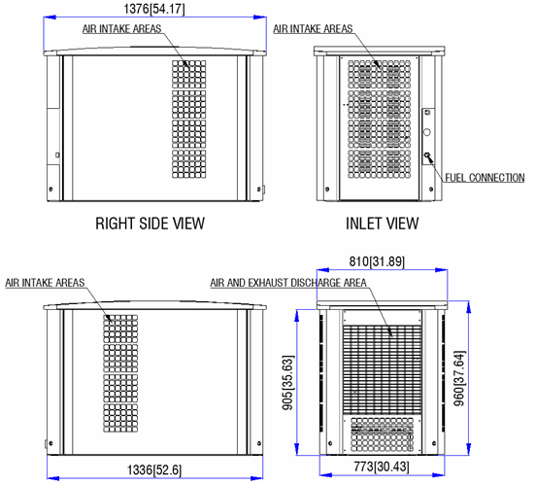

Control Features
CONTROLLER FEATURES
  - LCD display, easy to operate
  - System voltage/frequency selection and engine configuration
  - Maintain steady-state speed(stepping alternator)
  - High engine temperature
  - Low oil pressure
  - Over speed/Under speed
  - Crank cycle status
  - Over voltage/Under voltage
  - Charging system frailer
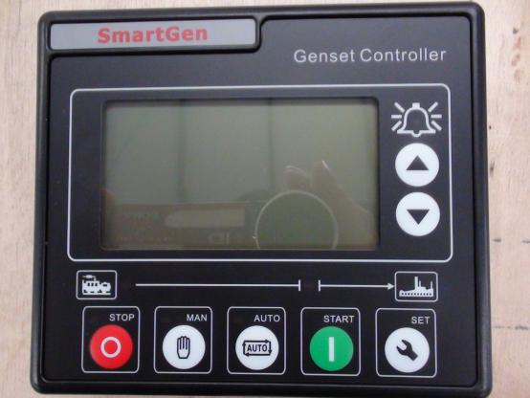
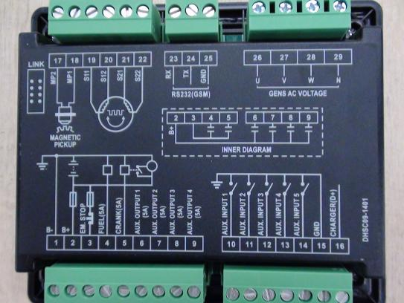
Transfer Switch
Pole | 2
Rated Current | 200A
Rated Volt | 250VAC
Max Volt | 300VAC
ATS Making Volt | 170V
ATS Breaking Volt | 150V
Withstand Rating | 10000A
Dimension（in） | 19.37×14.72×7.09
Operating Temp. | -20℃ to 70℃（-4℉ to 158℉）
Storage Temp. | -40℃to 85℃（-40℉ to 185℉）
Weight | 17.5kg
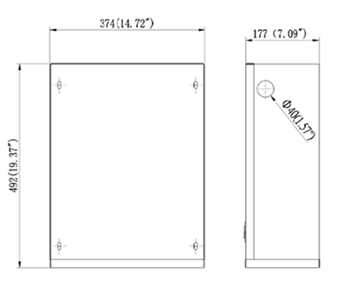
Company: GREENPOWER
Address:
Ph:
WWW.GREENPOWER.IR
Note
This outline drawing is provided for general reference only and is Not intended for use in design or installation. For more information, see Operators and Installation manuals or contact your distributor or dealer for assistance.
Available Accessories (Sold Separately)

● Battery
● Battery Charger
● Battery Heater
● Oil Heater
● GSM-3 GSM MODEM（Upload status of running to mobile and computer）

Emission System and Maintenance

1. The emission system and its running condition is a vital part of the generator and its overall performance. If this system is maintained and checked on a regular basis, the standby generator will provide decades of dependable service. It is extremely important to listen and visually inspect the generator from time to time during regular operation or during routine exercise mode. If smoke or unusual smells or sounds are experienced, push emergency stop switch and do not run the devices until full inspection has been performed by authorized service provider. The following parts are available by the manufacturer through . Any non-original equipment (O.E) or approved part will void warranty and could alter emission control requirements.
Part Name | Drawing Number | Part Number | Qty per Unit
Air Filter | 025A0120 | 2060005016 | 1
Muffler | 020B0050 | 2120001044 | 1
Igniter | 025A0121 | 2020003008 | 1
Spark Plug | 025A0122 | 2020004004 | 4
Mixer | 015A0106 | 2060004017 | 1
Sensors
Speed Sensor | 015A0418 | 2050001005 | 1
Crankshaft Position Sensor | 020A0123 | 2050001005 | 1
Water Temp Sensor | 015A0405 | 2050001043 | 1
Oil Sensor | 020A0124 | 2050001054 | 1
Intake Pressure Sensor | 020A0999 | 2050001042 | 1
Camshaft Position Sensor | 020A0126 | 2050001017 | 1
Oxygen Sensor | 020A0127 | 2050001041 | 1
Electrical Control Components
ECU | 020A0128 | 2030021002 | 1
Actuator | 020A0129 | 2060004009 | 1
Engine
PD465QR | 020A0009 | 2050012009 | 1
Mechanical Components
Catalytic Converter | 020A0104 | 2120001037 | 1
Fuel Switch Valve | 020A5250 | 2060002001 | 1
Regulator | 020A0006 | 2060001003 | 1

2. Maintenance
The maintenance of emission control device or system is as follows:
Maintenance Item | Checking Points | Corrective Action
Air filter | - Check the air filter element to verify if it is blocked or turn black  2. Verify the damage on the surface of the air filter | replacement
Muffler | Start device any abnormal sounds or air leakage | replacement
Igniter | Device cannot be started or hunting or igniter keeps firing the engine | replace
Spark Plug | - Device runs with hunting or without ignition;  2. Burned Spark plugs | replace
Mixer | The air intake holes been blocked | clean
Speed Sensor | Review the speed on controller, if it is 3600 RPM | replacement
Crankshaft Position Sensor | If generator runs steadily | replacement
Water Temp Sensor | Review the water temp on controller | replacement
Oil Sensor | If generator runs steadily | replacement
Intake Pressure Sensor | If generator runs steadily | replacement
Camshaft Position Sensor | If generator runs steadily | replacement
Oxygen Sensor | If it is with normal exhaust emission | replacement
ECU | Generator can be started and run steadily | replacement
Actuator | If the speed is 3600 RPM and frequency display 60HZ range | replacement
Engine PD465QR | - Check the oil;  2. Any oil leakage, runs steadily 3. Any abnormal noise exists | maintenance
Ternary Catalytic | Any foreign article in exhaust or with pungent smell | replacement
Fuel Switch Valve | Device can be stated with enough output | replacement
Regulator | If Generator can be started | replacement

OWNER’S WARRANTY RESPONSIBILITIES:
The owner will be responsible for the following:
● Installing, operating, commissioning and maintaining the product in accordance with GREENPOWER published policies and guidelines.
● Notifying GREENPOWER within 30 days of the discovery of failure.
● Providing evidence for date of purchase.
● Providing sufficient access to and reasonable ability to remove the product from the installation in the event of a warrantable failure.
In addition, the owner will be responsible for:
● Incremental costs and expenses associated with product removal and re-installation resulting from non-standard installations.
● Costs associated with rental of generator sets used to replace the product being repaired.
● Costs associated with labor overtime and premium shipping requested by the owner.
● Labor and travel after the base warranty period expires.
● All downtime expenses, fines, all applicable taxes, and other losses resulting from a warrantable failure.
If you have any questions regarding your warranty rights and responsibilities, you should contact a
service representative at ？, Ph, address.

RESPONSIBILITIES:
In the event of a failure of the product during the limited warranty period due to defects in material or workmanship, GREENPOWER will only be responsible for the following costs:
● All parts and labor required to repair the product.
● Reasonable travel expenses to and from the product site location.

LIMITATIONS:
This limited warranty does not cover product failures resulting from:
● Inappropriate use relative to designated power rating.
● Inappropriate use relative to application guidelines.
● Non-conformance to applicable industry standards for installation.
● Normal wear and tear.
● Improper and/or unauthorized installation.
● Owner’s or operator’s negligence, accidents or misuse.
● Lack of maintenance or unauthorized repair.
● Noncompliance with any published guideline or policy for the product.
● Improper storage before and after commissioning.
● Owner’s delay in making product available after notification of potential product problem.
● Use of steel enclosures within 60 miles of the coast of salt water when aluminum or an alternate non-corrosive material enclosure option is available.
● Replacement parts and accessories not authorized by GREENPOWER.
● Owner or operator abuse or neglect such as: late servicing and maintenance and improper storage.
● Damage to parts, fixtures, housings, attachments and accessory items that are not part of the transfer switch or paralleling system.
This limited extended warranty does not cover costs resulting from:
● Difficulty in gaining access to the product.
● Repair of cosmetic damage to enclosures.
COMPONENTS COVERED:
The emission-related warranty covers all components whose failure would increase an engine's
emissions of any regulated pollutant, including components listed in 40 CFR part 1068, Appendix I, and components from any other system you develop to control emissions. The emission-related warranty covers these components even if another company produces the component. Your emission-related warranty does not cover components whose failure would not increase an engine's emissions of any regulated pollutant.

